**Name: Muhammad Ali Registration No: 19PWCSE1801**

**DCN Summer Project 2023:**

**Subnetting a University Network**

**Objective:**

* Make the given network on packet tracer and label all the blocks
* Divide the network into subnets using Fixed Length Subnet Mask.
* Assign the addresses to the devices.
* Check connectivity and troubleshoot the network if required.
* Write the project report.

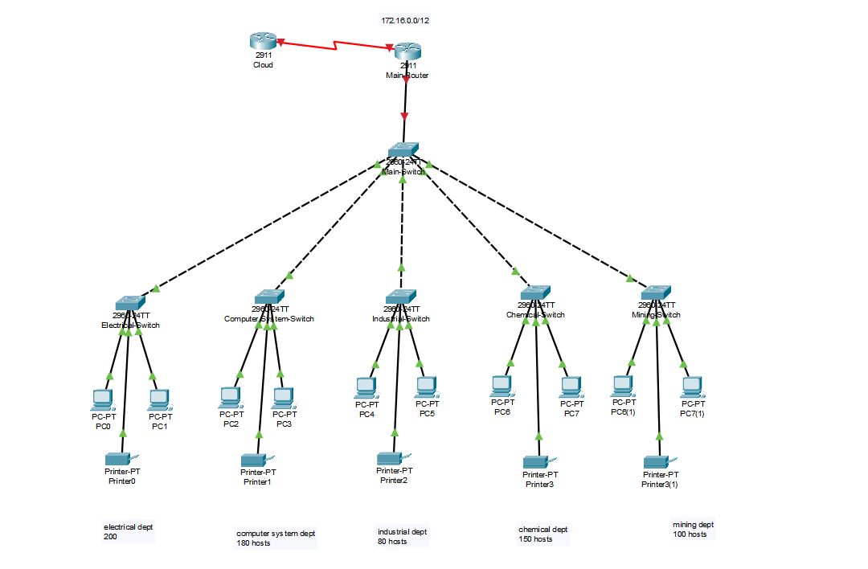

**Background:**

The given network is designed for five departments of a university. Each department has a different number of hosts and one subnet mask. There are end devices like PCs, Laptops and printers present in each department as hosts and each is connected to the network using a switch. The IP address given is 172.16.0.0/16, divide the address into subnets and assign each subnet to a department.

**Verify Connectivity:**

Verify the connectivity within the network. Ping different PCs, switches, and routers to check connectivity of the network.

**PROJECT REPORT**

**Requirement: -**

We have five departments with different host requirements as follows:

Department A: 200 hosts

Department B: 180 hosts

Department C: 80 hosts

Department D: 150 hosts

Department E: 100 hosts

**Subnetting: -**

**Subnetting based FLSM: -**

**Department A: -**

**Subnet**: 172.16.0.0/24

**Usable IP Range:** 172.16.0.1 to 172.16.0.254

**Default Gateway:** 172.16.0.1

**Department B: -**

Subnet: 172.16.1.0/24

Usable IP Range: 172.16.1.1 to 172.16.1.254

Default Gateway: 172.16.1.1

**Department C: -**

Subnet: 172.16.2.0/24

Usable IP Range: 172.16.2.1 to 172.16.2.254

Default Gateway: 172.16.2.1

**Department D: -**

Subnet: 172.16.3.0/24

Usable IP Range: 172.16.3.1 to 172.16.3.254

Default Gateway: 172.16.3.1

**Department E: -**

Subnet: 172.16.4.0/24

Usable IP Range: 172.16.4.1 to 172.16.4.254

Default Gateway: 172.16.4.1

With this FLSM configuration, all departments share the same /24 subnet mask, and each department is allocated its own IP address range within that subnet.Top of Form

**Network in Packet Tracer: -**

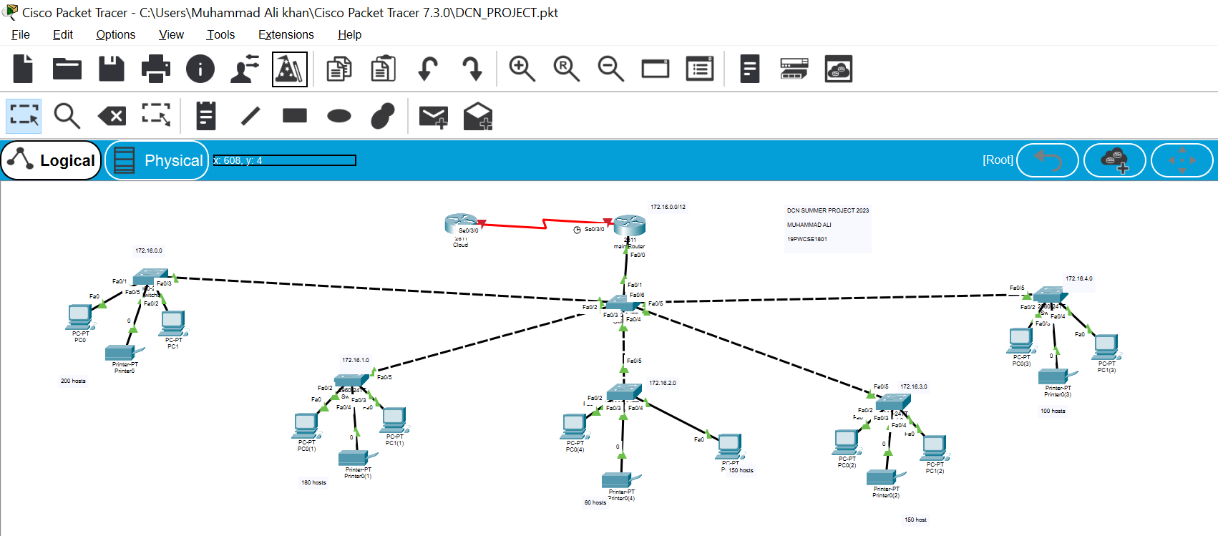

**Exceptional Project Part: -**

**Subnetting based on VLSM: -**

We have five departments with different host requirements as follows:

Department A: 200 hosts

Department B: 180 hosts

Department C: 80 hosts

Department D: 150 hosts

Department E: 100 hosts

Let's calculate the subnet masks for each department based on their host requirements:

Department A: 200 hosts (2^8 ≥ 200, so we need 8 host bits) Subnet Mask: /24 (255.255.255.0)

Department B: 180 hosts (2^8 ≥ 180, so we need 8 host bits) Subnet Mask: /24 (255.255.255.0)

Department C: 80 hosts (2^7 ≥ 80, so we need 7 host bits) Subnet Mask: /25 (255.255.255.128)

Department D: 150 hosts (2^8 ≥ 150, so we need 8 host bits) Subnet Mask: /24 (255.255.255.0)

Department E: 100 hosts (2^7 ≥ 100, so we need 7 host bits) Subnet Mask: /25 (255.255.255.128)

**Subnetting: -**

Now, let's divide the given IP address (172.16.0.0/16) into these subnets:

**Department A:**

Subnet: 172.16.0.0/24

Usable IP Range: 172.16.0.1 to 172.16.0.254

**Department B:**

Subnet: 172.16.1.0/24

Usable IP Range: 172.16.1.1 to 172.16.1.254

**Department C:**

Subnet: 172.16.2.0/25

Usable IP Range: 172.16.2.1 to 172.16.2.126

**Department D:**

Subnet: 172.16.2.128/24

Usable IP Range: 172.16.2.129 to 172.16.2.254

**Department E:**

Subnet: 172.16.3.0/25

Usable IP Range: 172.16.3.1 to 172.16.3.126

We can now configure these subnets in our network in Cisco Packet Tracer, assign the IP address ranges to the respective VLANs, and connect devices accordingly. Configure routing if needed for inter-department communication or external network access.

Top of Form